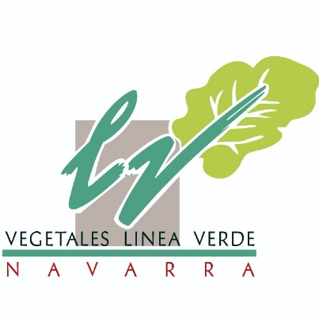VEGETALES LINEA VERDE NAVARRA S.A.

Carta, Corella, KM 3

31500- Tudela

In Tudela, on March 21, 2022

Dear,

we have concluded that your quarterly paid vacation will be April 29 to resume work on Friday March 20.

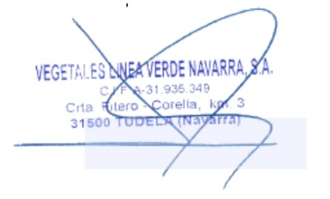 Without another particular, I greet you sincerely.

John ikechukwu Alfred Company Sign.

NIE: Y0166311N